TranslateMe App - Walkthrough

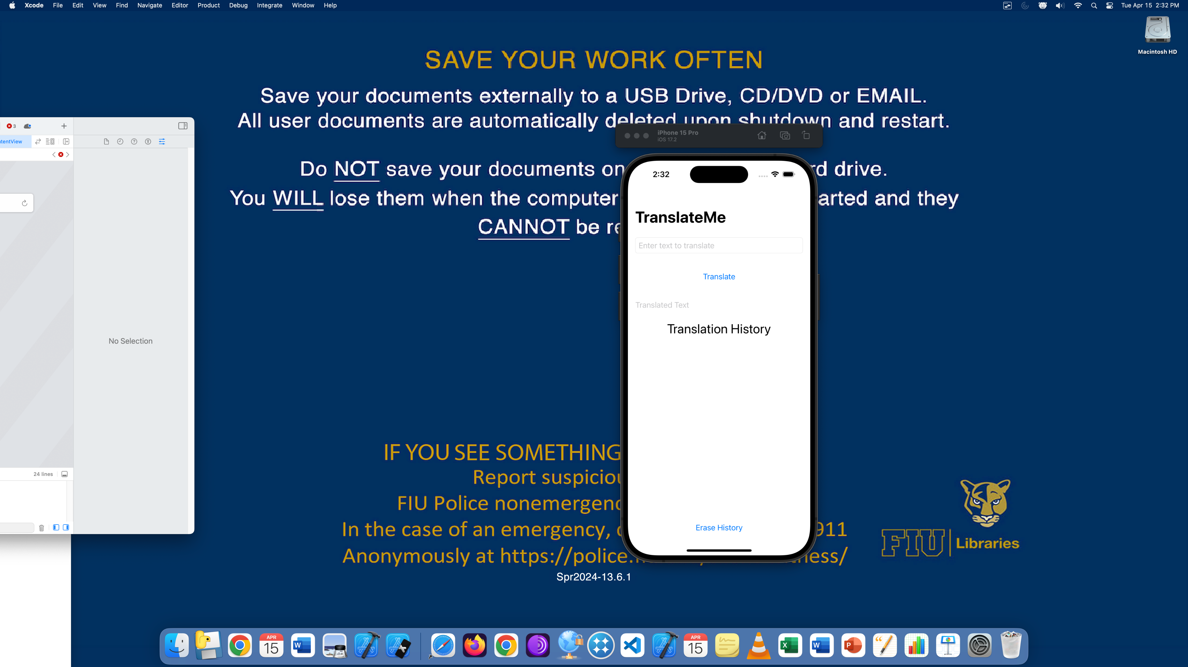

App launch screen with input field, translate button, and empty output/history section.

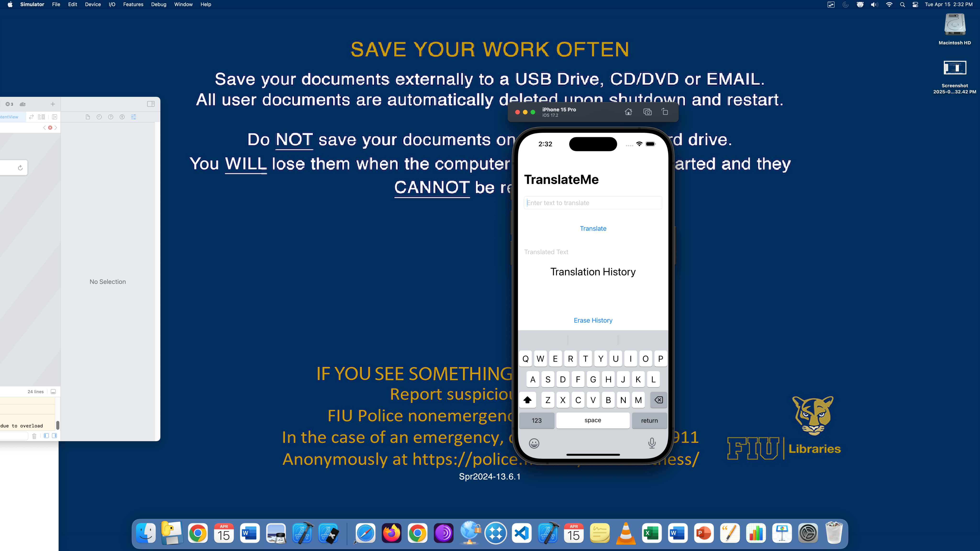

User begins typing 'Hello World' into the input field.

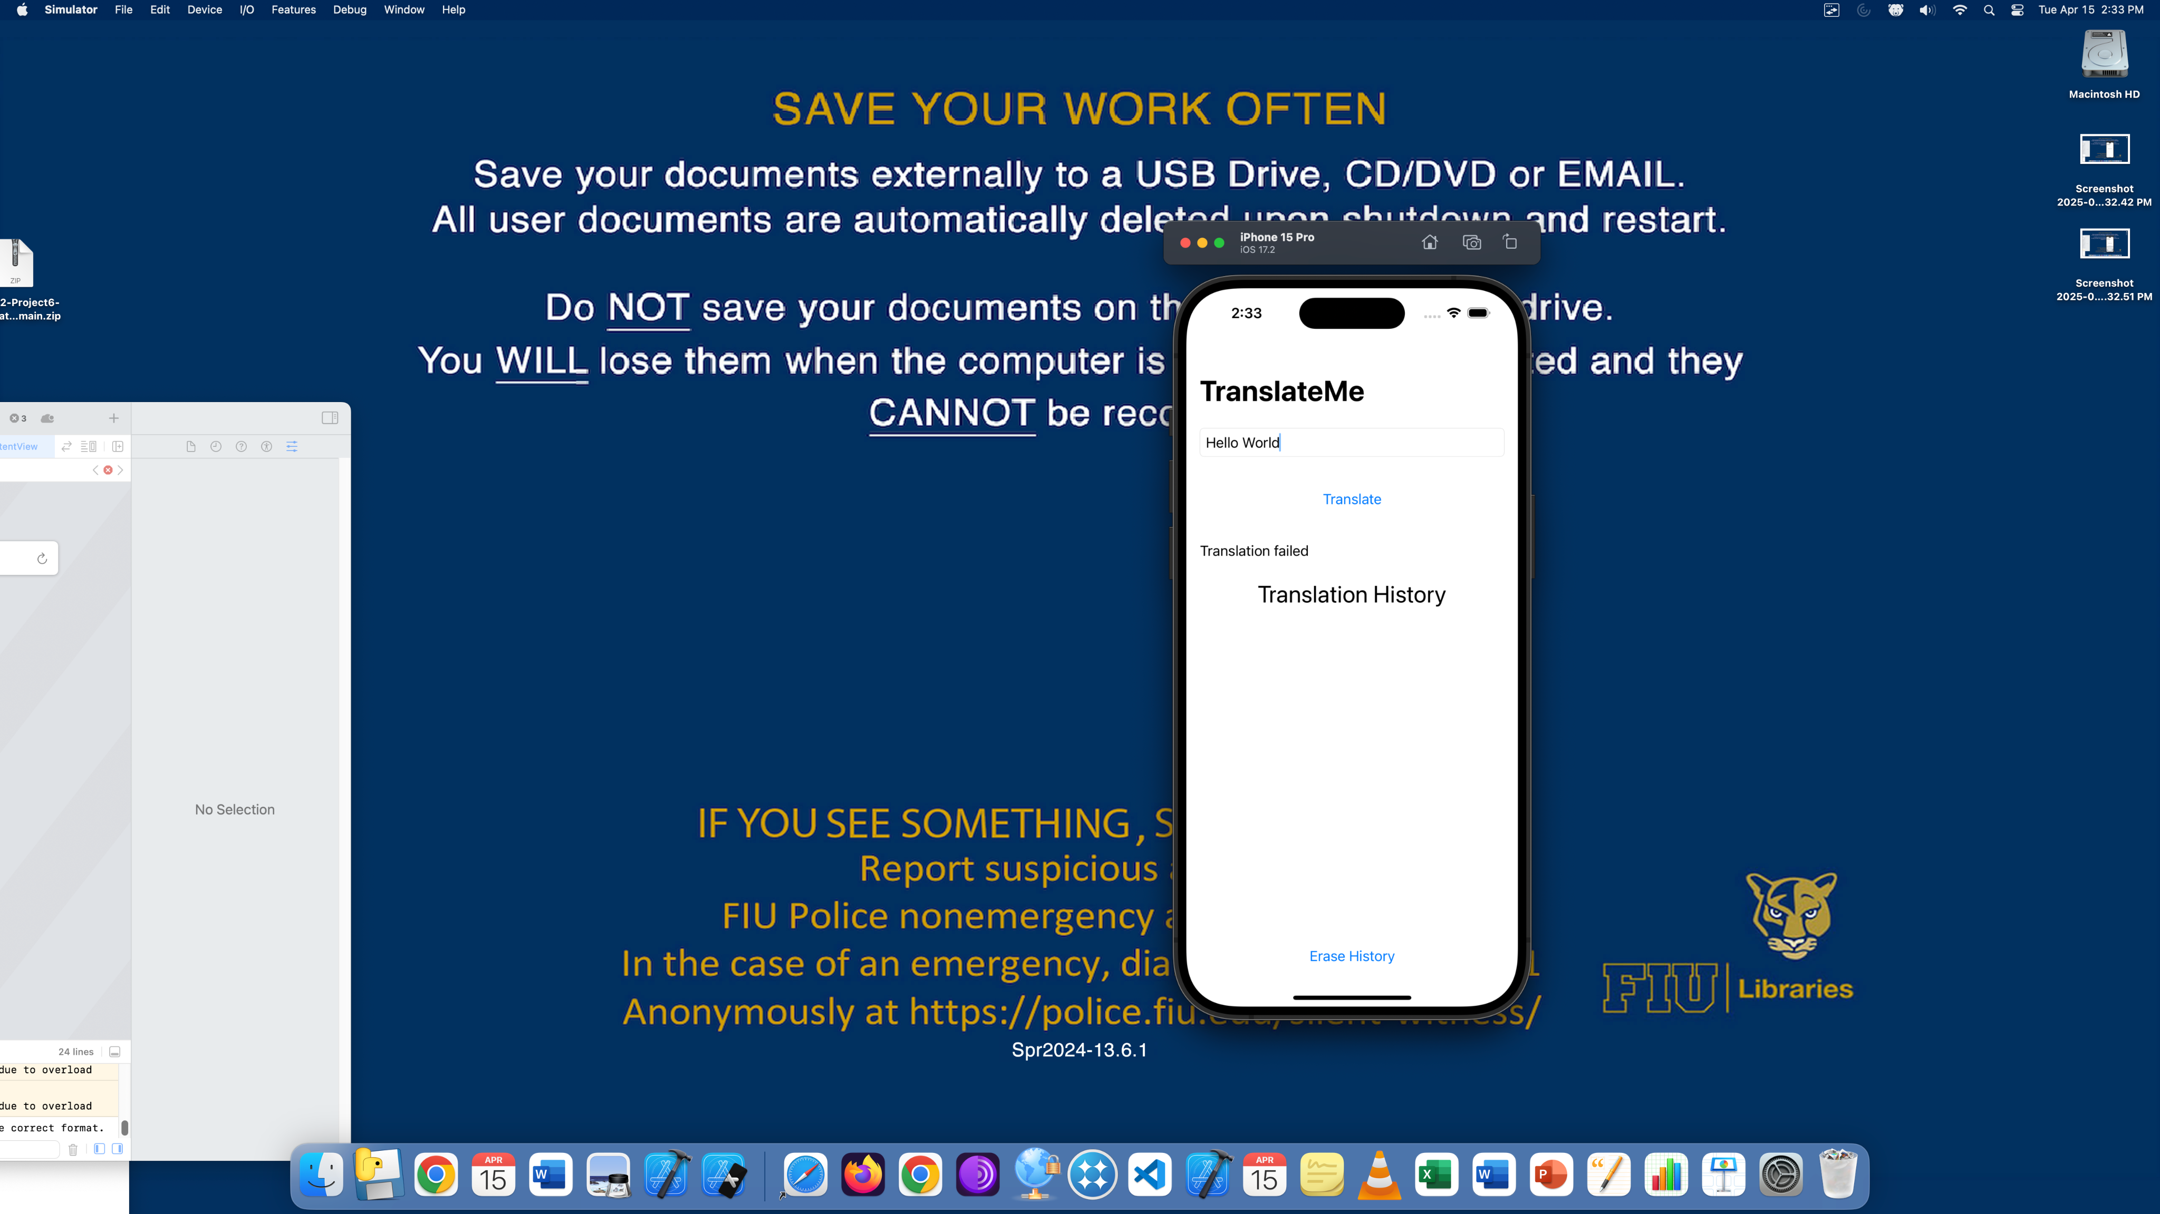

'Translate' button pressed, but translation failed. Message shown below and history starts to populate.

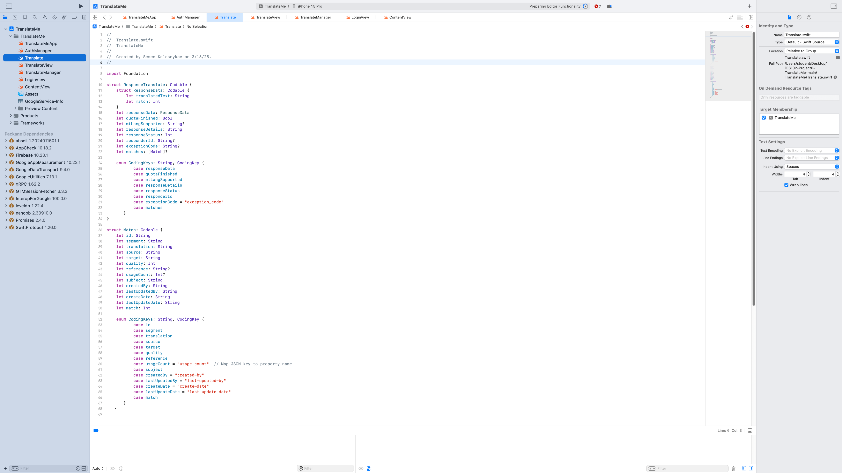

Translate.swift file: response model for parsing API response.

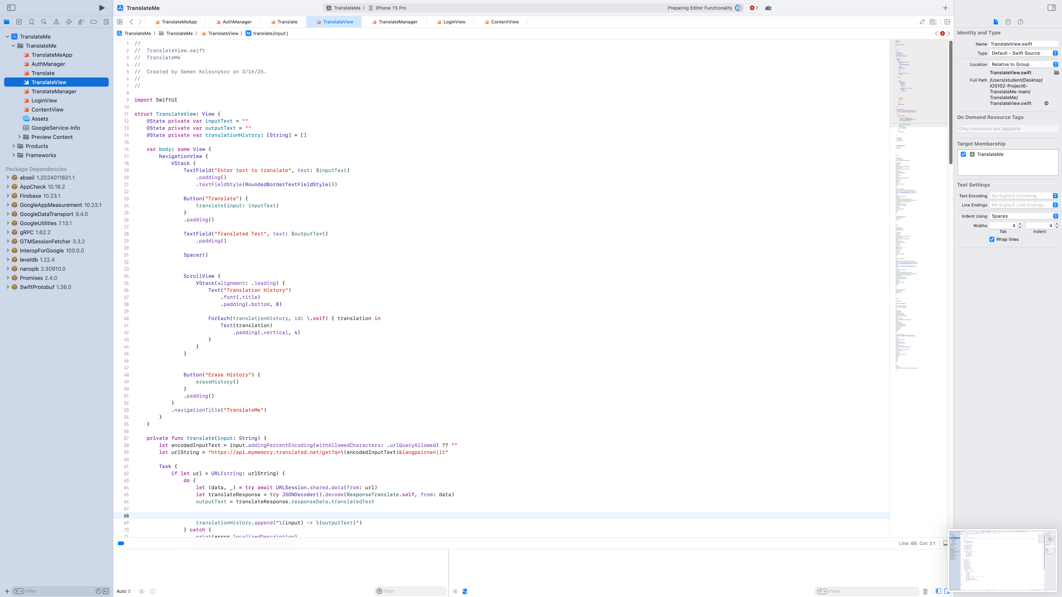

TranslateView.swift: translation logic and view layout.

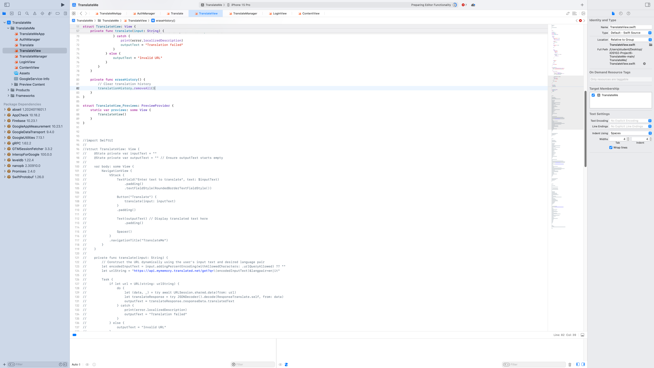

ScrollView with translation history display.

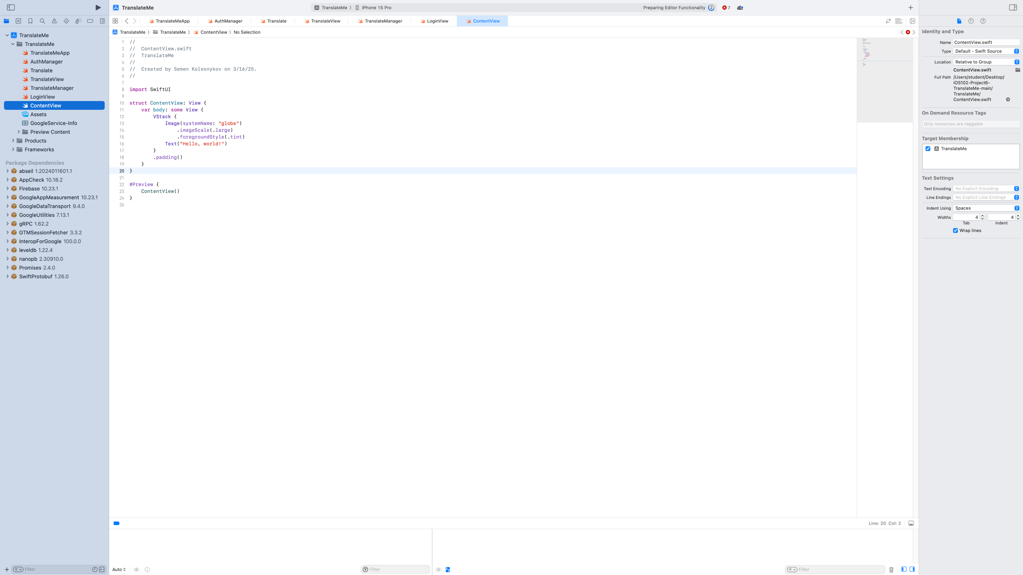

TranslateView continues: eraseHistory function to clear stored translations.